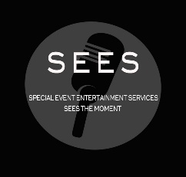
SPECIAL EVENT ENTERTAINMENT SERVICES
10932 Nord Ave S. Bloomington, MN 55437
612 – 388-9825
PRELIMINARY EVENT INFORMATION SHEET

EVENT DATE: |  | START TIME: |  |  | END TIME:
EVENT BUDGET: |  |  | VENUE:
NUMBER OF GUESTS: |  |  | AGE RANGE OF GUESTS:
 | Corporate  Lecture  Meeting  Social Gathering  Wedding  Groom’s Dinner  Ceremony  Reception |  |  | Social Gathering  Anniversary  Baby Shower  Birthday  Family Reunion  Graduation  Retirement  Other
SERVICES: Describe services needed below; Decorating, Catering, etc.
Limited Planning Services
Full Service Planning

ENTERTAINMENT: Describe type of entertainment needed below, if applicable

POINT OF CONTACT: | PHONE:

A QUOTE WILL BE PROVIDED UPON RECEIPT - THANK YOU!

